GOBIERNO DEL ESTADO DE MÉXICO

Foto

DIRECCIÓN GENERAL DE EDUCACIÓN

DEPARTAMENTO DE EDUCACIÓN SECUNDARIA

**1ro**

**Grado:**

**Esc. Sec. Ofic. No. 0438**

“Lic. Mario Colín Sánchez”

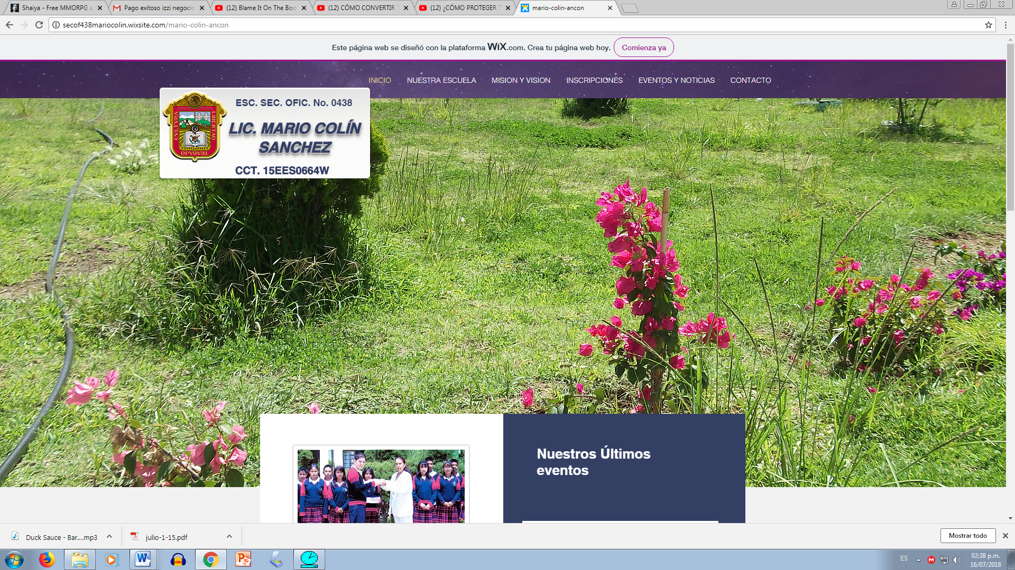**SOLICITUD DE INSCRIPCIÓN 2023 - 2024**

Indicaciones. Lea cuidadosamente antes de llenar la presente solicitud de inscripción, no podrá dejar espacios vacíos o incompletos.

1. **Datos del Alumno**

|  |  |  |  |  |  |  |  |  |  |  |  |  |  |  |  |  |  |  |  |  |  |  |  |  |  |  |  |  |  |  |  |  |  |  |  |  |  |  |  |  |  |  |  |  |  |  |  |  |  |  |  |  |  |  |  |  |  |  |  |  |  |  |  |  |  |  |  |  |  |  |  |  |
| --- | --- | --- | --- | --- | --- | --- | --- | --- | --- | --- | --- | --- | --- | --- | --- | --- | --- | --- | --- | --- | --- | --- | --- | --- | --- | --- | --- | --- | --- | --- | --- | --- | --- | --- | --- | --- | --- | --- | --- | --- | --- | --- | --- | --- | --- | --- | --- | --- | --- | --- | --- | --- | --- | --- | --- | --- | --- | --- | --- | --- | --- | --- | --- | --- | --- | --- | --- | --- | --- | --- | --- | --- |
| **Ocupación** | | | | | |  | | | | | | | | | **Discapacidad:** | | | | | | | | | |  | | | | | | | | **Nacionalidad:** | | | | | | | | | |  | | | | | | | | | |  | | | | | **Turno** | | | | | | **Matutino** | | | | | | | |  |
| **Nombre completo del alumno(a):** | | | | | | | | | | | | | | | | | | **Sexo:** | | | | |  | | | | | | | | | **Edad:** | | | | |  | | | | **Años** | | | | |  | | | | **Meses** | | | | | | | | **Fecha de nacimiento** | | | | | | | | | | | | | | |
|  | | | | | | | | | |  |  | | | | | | | | | | | | | |  | | |  | | | | | | | | | | | | | | | | | | | | | | | | | | |  | | | **Día** | | | |  | **Mes** | | | | | | |  | **Año** | |
| **Apellido Paterno** | | | | | | | | | |  | **Apellido Materno** | | | | | | | | | | | | | |  | | | **Nombre (s)** | | | | | | | | | | | | | | | | | | | | | | | | | | |  | | |  | | | |  |  | | | | | | |  |  | |
| **Lugar de nacimiento** | | | | | | | | |  | | | | | | | | | | | | | |  | | | |  | | | | | | | | | | | | |  | **¿Usa lentes?** | | | | | | | | | | |  | | | | | | | **¿Usa zapato ortopédico?** | | | | | | | | | | | |  | |
|  |  |  | |  | | |  | | **Delegación o municipio** | | | | | | | | | | | | | |  | | | | **Estado** | | | | | | | | | | | | |  |  | | | | | | | | |  | | | | | | | | | | | | | | | | | | | | | | |
| **Estatura** | | |  | | | | | **Mts** | | |  | **Peso** | | | | | | |  | | | **Kg** | | | | |  | | **Tipo de sangre** | | | | | | | | |  | | | | | | | | | |  | | **Clave única de Registro de Población (CURP)** | | | | | | | | | | | | | | | | | | | | | | |
| **Cuenta con cartilla de vacunación Marque con una “X”** | | | | | | | | | | | | | | **Si** | | | | |  | |  |  | | | | | | | | | | | | | | | | | | | | | | | | | |  | |  | | | | | | | | | | | | | | | | | | | | | | |
| **No** | | | | |  | |  | **Tiene Alguna alergia(s)** | | | | | | | | | | | | | | | | | | | | | | | | | |  | | **Tiene alguna enfermedad crónica** | | | | | | | | | | | | | | | | | | | | | | |
| **Domicilio:** | | | | | | | |  | | |  |  | | | | | | | | | | |  | | |  | | |  | | | | | | | | | | |  |  | | | |  | |  | | |  | | | | | | | | | | | | | | | | | | | | | | |
|  | | | | | | | | | | | | | | | | |  | |  | | | | | |  | | |  | | | | |  | | | |  | | | | | |  | | |  | | | | | | |  | | |  | | | | | | | | | | | | | | | | |
| **Calle** | | | | | | | | | | | | | | | | |  | | **No. Exterior** | | | | | |  | | | **No. Interior** | | | | |  | | | | **Manzana** | | | | | |  | | | **Lote** | | | | | | |  | | | **Colonia o Barrio** | | | | | | | | | | | | | | | | |
|  | | | | | | | | | | | | | | | | | |  | |  | | | | | | | | | | | | | | | | | | | | |  |  | | | | | | | | | | | | | | | | | | | | | | |  | |  | | | | | |
| **Localidad** | | | | | | | | | | | | | | | | | |  | | **Municipio** | | | | | | | | | | | | | | | | | | | | |  | **Entidad federativa (Estado)** | | | | | | | | | | | | | | | | | | | | | | |  | | **Código postal** | | | | | |
|  | | | | | | | | | | | | | | | | | |  | |  | | | | | | | | | | | | | | | | | | | | |  |  | | | | | | | | | | | | | | | | | | | | | | | | | | | | | | |
| **Entre la calle** | | | | | | | | | | | | | | | | | |  | | **Y la calle** | | | | | | | | | | | | | | | | | | | | |  | **Otra referencia** | | | | | | | | | | | | | | | | | | | | | | | | | | | | | | |
|  | | | | | | | | | | |  |  | | | | | | | | | | | | | | | | | |  |  | | | | | | | | | | | | | | | | | |  | |  | | | | | | | | | | | | | | | | | | | | | |
| **Teléfono de casa** | | | | | | | | | | |  | **Teléfono de celular** | | | | | | | | | | | | | | | | | |  | **Teléfono de emergencias** | | | | | | | | | | | | | | | | | |  | | **Correo electrónico** | | | | | | | | | | | | | | | | | | | | | |
| **Escuela Primaria de procedencia:** | | | | | | | | | | | | | | | | | | | |  | | | | | | | | | | | | | | | | | | | | | | | | | | | | | | | | | | | | | | | | | **Generación:** | | | | | | |  | | | | |
| **Promedio del Reporte de evaluación 6to** | | | | | | | | | | | | | | | | | | | | |  | | | | | | | | |  | |  | | |  | | | |  | |  | | | | **Promedio del certificado de primaria** | | | | | | | | | | | | | | | | | | | | | | | |  | | | |
|  | | | | | | | | | | | | | | | | | | | | |  |  | | | | | | | | | | | | | | | | | | | | | | | | | | | | |  | | |  | | | | | | | | | | | | | | | | | | |
| **Tipo de Seguro Social** | | | | | | | | | | | | | | | | | | | | |  | **No. de afiliación de seguridad social** | | | | | | | | | | | | | | | | | | | | | | | | | | | | |  | | | **Lengua o dialecto (especifique)** | | | | | | | | | | | | | | | | | | |
| **Red Social 1** | | | | |  | | | | | | | |  | | | **ID red social 1** | | | | | | | |  | | | | | | | | | |  | | **Red Social 2** | | | | | | | |  | | | | | | | | | | | | |  | | | **ID red social 2** | | | | | |  | | | | | | |

1. **Datos del padre o tutor 1**

|  |  |  |  |  |  |  |  |  |  |  |  |  |  |  |  |  |  |  |  |  |  |  |  |  |  |  |  |  |  |  |  |  |  |  |  |  |  |
| --- | --- | --- | --- | --- | --- | --- | --- | --- | --- | --- | --- | --- | --- | --- | --- | --- | --- | --- | --- | --- | --- | --- | --- | --- | --- | --- | --- | --- | --- | --- | --- | --- | --- | --- | --- | --- | --- |
| **Nombre completo del padre o tutor(a) 1:** | | | | | | |  |  | |  | | **Estado civil:** | | | | | | | | |  | | | | | |  | **Escolaridad:** | | | |  | | | | | |
|  | |  | |  | | | | | | | | |  | |  | | | | | | | | | | | |  |  |  | |  |  |  | |  |  |  |
| **Apellido Paterno** | |  | | **Apellido Materno** | | | | | | | | |  | | **Nombre (s)** | | | | | | | | | | | |  | **Ocupación:** | | | |  | | | | | |
|  | |  | | **El Alumno Vive con el tutor** | | | | | | | | | | **Si** | | |  | | **Marque con una “X”** | | | |  | | |  |  |  | | | |  | | | | | |
| **Parentesco** | |  | | **No** | | |  | |  | | |  |  |  | | | |  | | | | | |
|  | | |  | |  | | | | | | | | |  | |  | | | | | | | |  | @ | | | | | | | | | | | | |
| **Teléfono de casa** | | |  | | **Teléfono de celular** | | | | | | | | |  | | **Teléfono de emergencias** | | | | | | | |  | **Correo electrónico** | | | | | | | | | | | | |
| **Red Social 1** |  | | | |  | **ID red social 1** | | |  | | | | | | | | |  | | **Red Social 2** | |  | | | | | |  | | **ID red social 2** | | | |  | | | |
|  | | | | | | | | | | |  | | | | | | |  | |  | |  | | | | | | | | | | | | | | | |
| **Clave única de Registro de Población (CURP)** | | | | | | | | | | |  | | | | | | |  | |  | | **Clave de elector (INE)** | | | | | | | | | | | | | | | |

1. **Datos del padre o tutor 2**

|  |  |  |  |  |  |  |  |  |  |  |  |  |  |  |  |  |  |  |  |  |  |  |  |  |  |  |  |  |  |  |  |  |  |  |  |  |  |
| --- | --- | --- | --- | --- | --- | --- | --- | --- | --- | --- | --- | --- | --- | --- | --- | --- | --- | --- | --- | --- | --- | --- | --- | --- | --- | --- | --- | --- | --- | --- | --- | --- | --- | --- | --- | --- | --- |
| **Nombre completo del padre o tutor(a) 2:** | | | | | | |  |  | |  | | **Estado civil:** | | | | | | | | |  | | | | | |  | **Escolaridad:** | | | |  | | | | | |
|  | |  | |  | | | | | | | | |  | |  | | | | | | | | | | | |  |  |  | |  |  |  | |  |  |  |
| **Apellido Paterno** | |  | | **Apellido Materno** | | | | | | | | |  | | **Nombre (s)** | | | | | | | | | | | |  | **Ocupación:** | | | |  | | | | | |
|  | |  | | **El Alumno Vive con el tutor** | | | | | | | | | | **Si** | | |  | | **Marque con una “X”** | | | |  | | |  |  |  | | | |  | | | | | |
| **Parentesco** | |  | | **No** | | |  | |  | | |  |  |  | | | |  | | | | | |
|  | | |  | |  | | | | | | | | |  | |  | | | | | | | |  | @ | | | | | | | | | | | | |
| **Teléfono de casa** | | |  | | **Teléfono de celular** | | | | | | | | |  | | **Teléfono de emergencias** | | | | | | | |  | **Correo electrónico** | | | | | | | | | | | | |
| **Red Social 1** |  | | | |  | **ID red social 1** | | |  | | | | | | | | |  | | **Red Social 2** | |  | | | | | |  | | **ID red social 2** | | | |  | | | |
|  | | | | | | | | | | |  | | | | | | |  | |  | |  | | | | | | | | | | | | | | | |
| **Clave única de Registro de Población (CURP)** | | | | | | | | | | |  | | | | | | |  | |  | | **Clave de elector (INE)** | | | | | | | | | | | | | | | |

1. **¿El estudiante cuenta con los siguientes apoyos para su aprendizaje?, Escriba (si ó no)**

|  |  |  |  |  |  |  |  |  |  |  |  |  |  |
| --- | --- | --- | --- | --- | --- | --- | --- | --- | --- | --- | --- | --- | --- |
|  |  |  |  |  |  |  |  |  |  |  |  |  |  |
| **Computadora de escritorio o portátil** |  | **Tablet** |  | **Internet en casa** |  | **Internet celular** |  | **Televisión de paga** |  | **Televisión abierta** |  | **Radio** |  |
|  | | | | |  |  | | |  |  |  |  |  |
| **Con quien vive el alumno (papa, mama, ambos, especificar)** | | | | |  | **Cuantos hermanos tiene** | | |  |  |  |  |  |